Project Title: Operational User Guide: BubblesO2 All-in-One (AIO) System – Sales Ordering Module
User: Iskandar Department: IT Department Date: 28/7/2026
Target Audience: Sales Ordering Department (SOD)

for BubblesO2 Marketing SDN BHD

Prepared by,
Muhammad Iskandar Zulkarnain Bin Zulkifli System Developer,
Information Technology,
Information Technology Department
1.0 EXECUTIVE SUMMARY & SYSTEM OBJECTIVE
This document serves as the comprehensive Step-by-Step Operational User Manual for the Sales Ordering module within the BubblesO2 All-in-One (AIO) System. This module is engineered to standardize, expedite, and automate incoming customer purchase order (PO) processing—from initial customer onboarding to commercial draft sales order generation.
The core objectives of this module include:
- AI-Powered Document Extraction: Minimizing manual data entry errors by leveraging Gemini AI models to accurately read and extract structured data from PDF Purchase Orders (PO) and Statements of Account (SOA).
- Automated Credit Risk & Ledger Controls: Protecting BubblesO2 from overdue debt through an automated 5-point verification check (credit limit checks, overdue aging tolerance, and entity reconciliation) before orders can proceed.
- Cross-Departmental Collaboration: Unifying BD, SOD, and Finance teams within a single digital platform, featuring automated email alerts to the BD team whenever an order faces credit rejection.

2.0 SYSTEM ACCESS & NAVIGATION PREREQUISITES
Before processing orders, ensure that SOD and BD personnel have an active workstation with a modern web browser (Google Chrome / Microsoft Edge) and authorized corporate login credentials.
1. Open your web browser and navigate to the internal portal: https://aio.bubbleso2.com (or the designated internal company URL).
2. Log in using your registered corporate email and password.
3. On the left navigation bar (Sidebar), click on the Sales Ordering module (/forms/sales-ordering).
The Sales Ordering module features seven (7) primary navigation sub-topics:
- Dashboard: High-level statistical overview, pipeline completion rates, and rejection alert banners.
- PO Customer: Central tracking view for all customer POs, multi-PO splits, and SOA approval statuses.
- AI Intake: Document reception queue for automated PO/Invoice PDF scanning and extraction.
- PO-SOA Check: Financial credit risk evaluation and ledger reconciliation workspace.
- Sales Orders: Repository of all generated commercial draft sales orders.
- Customers: Searchable Customer Master List and pending Google Form registration reviews.
- Database: System purge and maintenance utility (strictly restricted to SuperAdmin access).
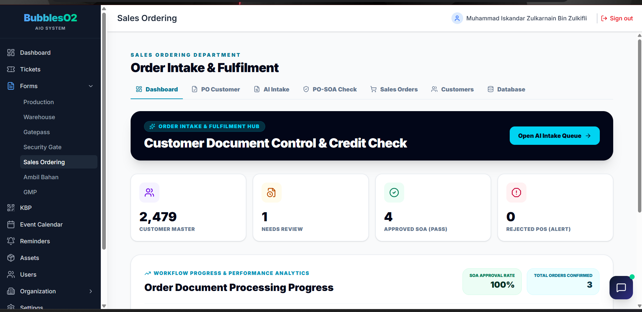

3.0 STEP-BY-STEP OPERATIONAL GUIDE FOR SOD & BD TEAM
The end-to-end SOD operational workflow is structured into six (6) progressive stages:
OPERATIONAL END-TO-END WORKFLOW
[Step 1: Customer Onboarding & Master Verification]
↓
[Step 2: PO / Invoice Document Intake (AI Extraction)]
↓
[Step 3: Reviewing Extracted PO Data & Routing (Intake Review)]
↓
[Step 4: Financial Credit Risk Evaluation (PO-SOA Check)]
↓
[Step 5: Commercial Draft Sales Order Creation]
↓
[Step 6: Exporting Approved Sales Orders to Excel]

3.1 STEP 1: CUSTOMER ONBOARDING & MASTER VERIFICATION
For new corporate clients, company details must be reviewed and officially approved before any Sales Order can be generated.
Incoming Customer Applications:
- The prospective client completes the official BubblesO2 Customer Registration Google Form provided by the BD team.
- Form submissions sync automatically into the AIO System via a secure webhook with a default status of PENDING.
Accessing Applications:
- Click the Customers sub-topic tab, then select the Pending Registrations (Google Form) sub-tab.
- The badge counter displays the number of applications currently awaiting review.
- Click the Review Application button on the target customer row.

Document & Compliance Verification (Review Modal):
- Section A (Company & Business Information): Verify Legal Company Name, New/Old Registration No (SSM), and Business Commencement Date.
- Section B (Financial & Tax Information): Verify TIN No, SST No, Paid-Up Capital, and Estimated Annual Turnover.
- Section C (Premises & Addresses): Review the registered office address and business operational address.
- Section D (Contact Persons & Documents): Verify the primary Person-in-Charge (PIC), contact phone, billing email, and attached supporting documents (Bank Statements / SSM Certificate).
Approval Decision:
- If Approved: Click the green Approve & Create Customer Master button. The system automatically issues a standardized Customer Code (e.g., CUST-2026-001) and registers the account in the Customer Master List.
- If Incomplete / Rejected: Click the red Reject Registration button, provide a mandatory rejection justification in the text box, and click Confirm Rejection.
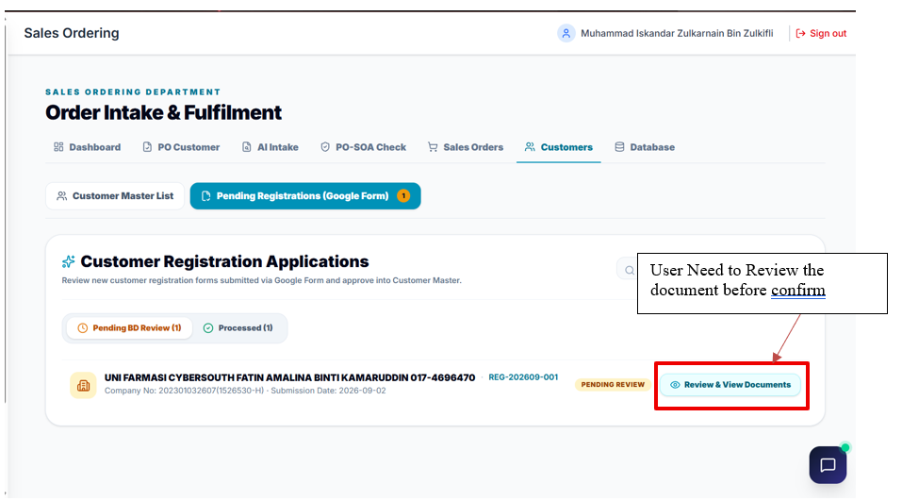

3.2 STEP 2: PO / INVOICE DOCUMENT INTAKE (AI-POWERED EXTRACTION)
Once the customer profile exists in the system, incoming customer Purchase Orders (PO) or Invoices can be uploaded.
1. Click on the AI Intake sub-topic tab (/forms/sales-ordering/intake).
2. In the Dropzone area at the top of the page: Click Select PDF to Upload or drag-and-drop the customer's PO PDF file (maximum file size: 20 MB).
3. Automated AI Processing (3 Stages):
- Stage 1 (Uploading PDF...): Securely uploads the document to private Cloudflare R2 object storage.
- Stage 2 (Reading PO / Invoices with AI...): The Gemini AI model extracts document headers, dates, customer references, product line items, quantities, and pricing.
- Stage 3 (Verifying extraction accuracy...): Runs an automated integrity pass to validate arithmetic subtotals, tax figures, and grand totals.
4. Once completed, the document appears in the AI Document Intake Queue with a Review action button.
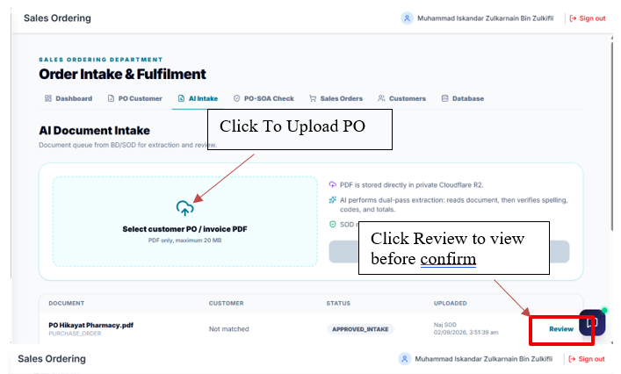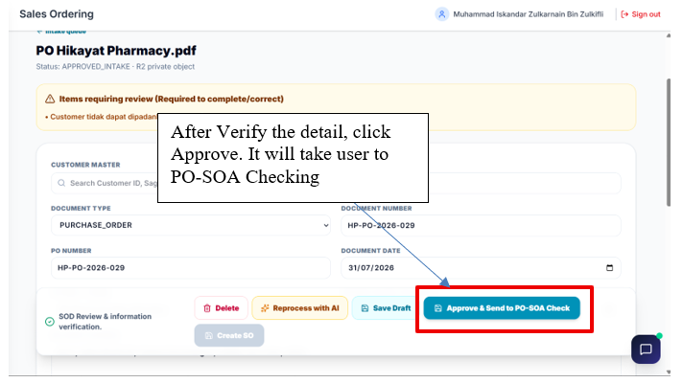
3.3 STEP 3: REVIEWING EXTRACTED PO DATA & ROUTING (INTAKE REVIEW)
In this screen, SOD personnel verify the accuracy of the AI-extracted fields and determine the downstream path for the order.
1. Click the Review button on the target document row within the Intake queue.
Customer Matching:
- Verify whether the system successfully matched the customer name against an existing Customer Master record.
- If marked as Not matched, select the correct customer from the dropdown selector.
Header Information Verification:
- Confirm the PO Number, Document Date, and Requested Delivery Date.
- Verify the Billing Address and Delivery Address.
Product Line Items & Charges:
- Audit the item table: SKU/Item Code, Product Description, Ordered Quantity (e.g., CTN), Unit Price (RM), and Line Total.
- Verify any service charges (e.g., freight, pallet, delivery surcharge) in the dedicated charges section.
- Multi-PO Notice: If the PDF contains multiple distinct purchase orders, sub-PO tabs will automatically appear at the top for individual review.
Workflow Routing Decisions (Two Options):
- Option A – Cash / Non-Credit Customer (Direct SO): For cash-on-delivery (COD) or pre-paid clients requiring no credit checks, click the green Approve & Create Sales Order button to immediately generate a Commercial Draft SO.
- Option B – Term Credit Customer (Forward to Credit Check): For credit-term clients (e.g., 30 Days / 60 Days), click the blue Forward to Credit Check button. The document transitions into the PO-SOA Check workflow under status PENDING_SOA.
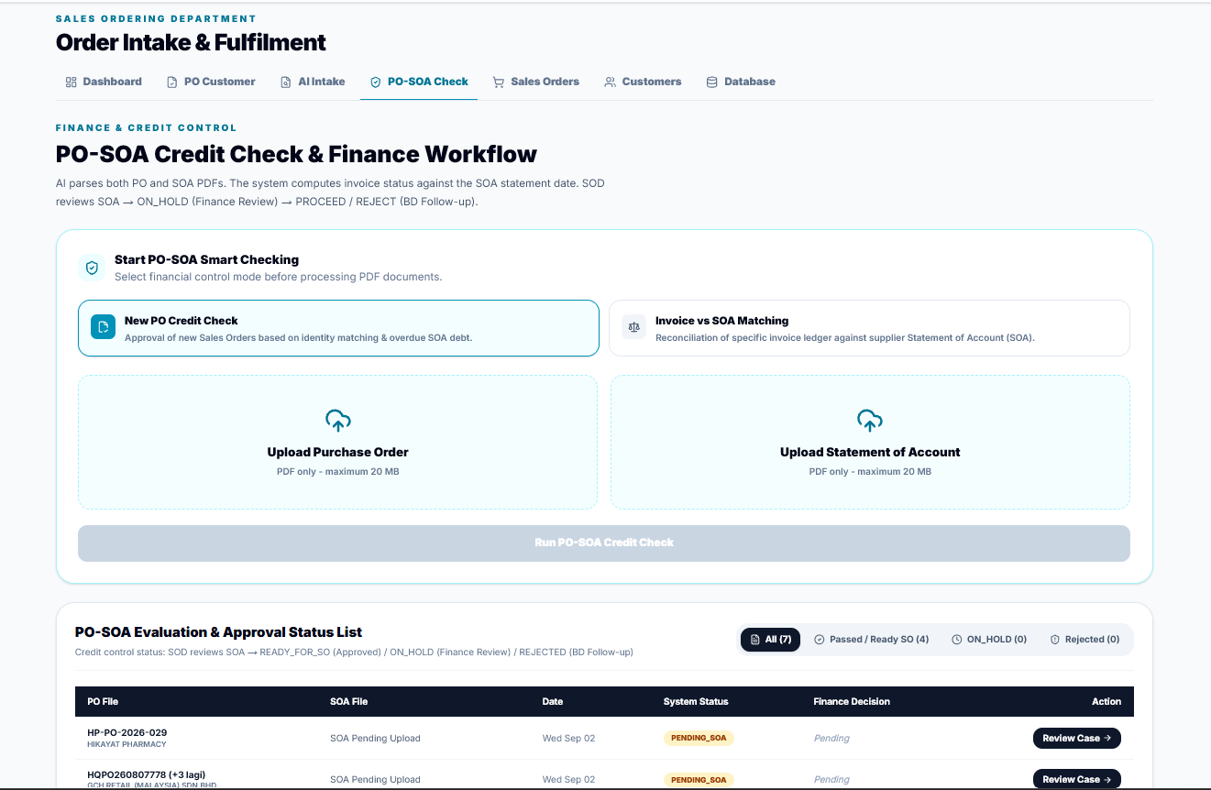

3.4 STEP 4: FINANCIAL CREDIT RISK EVALUATION (PO-SOA CREDIT CHECK)
This stage ensures BubblesO2 is protected against financial exposure and aging debt before orders are cleared for commercial fulfillment.
1. Click on the PO-SOA Check sub-topic tab (/forms/sales-ordering/credit-check).
2. Open the relevant case currently in PENDING_SOA status (or upload PO(From AI Intake) + SOA(From UBS) simultaneously via the dual uploader.
3. Upload the customer's official Statement of Account (SOA) in PDF file.
4. The AI extracts ledger balances and evaluates the 5 Key Financial Control Checks:
- Check 1 (Customer Identity Match): Verifies that the entity named on the PO matches the debtor name on the SOA ledger.
- Check 2 (Overdue Balance & Aging Tolerance): Evaluates outstanding debt strictly against the SOA Statement Date, applying dynamic aging tolerance based on the customer's credit terms.
- Check 3 (Credit Limit Breach): Checks whether the current ledger balance plus the new PO total exceeds the approved credit limit.
- Check 4 (Payment Terms Alignment): Ensures the payment terms stated on the PO align with the agreed credit terms recorded on the SOA.
- Check 5 (Invoice / PO Amount Matching): Reconciles invoice amounts against PO figures.
AI Recommendation Badges:
- 🟢 APPROVE: Low risk, zero overdue debt, and within credit limits. Ready for SO creation.
- 🟡 NEEDS_REVIEW / ON_HOLD: Minor discrepancies or borderline credit threshold. Requires Finance Officer intervention.
- 🔴 REJECT: Critical overdue debt or breached credit limit. Automatically dispatches an email alert to the BD team.

Finance Reviewer Action (Decision Form):
The Finance Officer inspects the Aging Breakdown summary cards (Current, 1 Month, 2 Months, 3 Months, 4 Months, 5+ Months). At the bottom decision panel, the Finance Officer submits:
- PROCEED: Clears the order for Sales Order creation.
- REJECT: Denies the order and triggers an immediate email notification to the BD team detailing the rejection cause.
- APPROVE_EXCEPTION: Conditional override. The officer must input a written justification and attach supporting evidence (e.g., interim payment slip or management authorization).
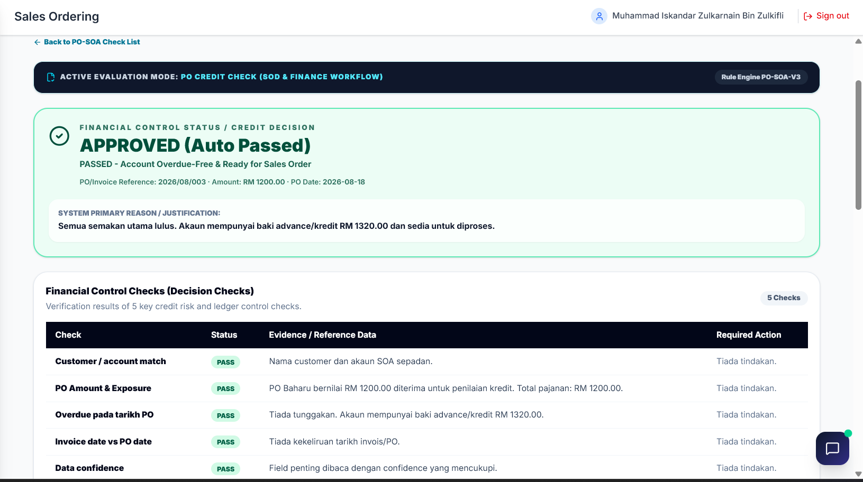
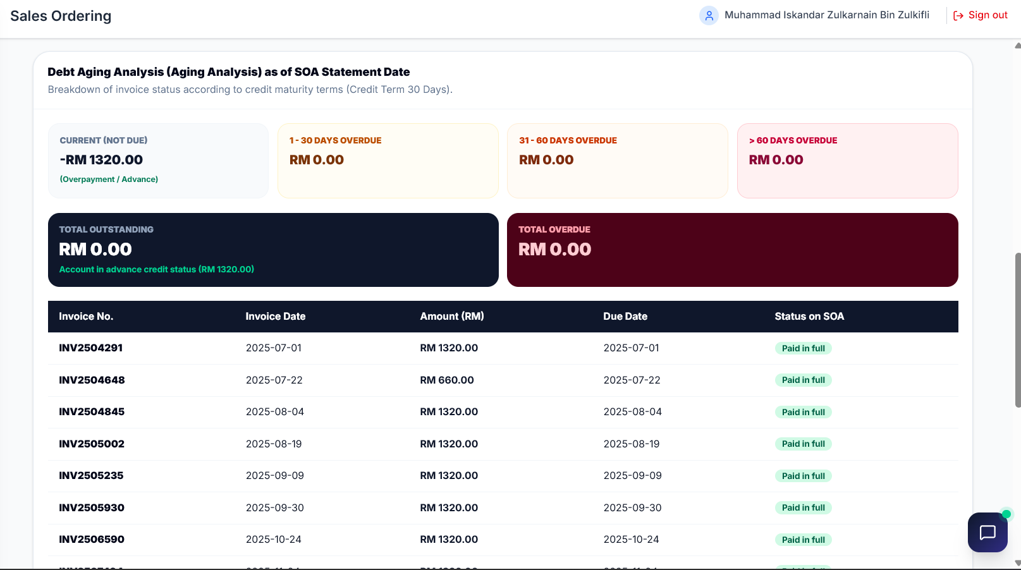

3.5 STEP 5: COMMERCIAL DRAFT SALES ORDER CREATION & MANAGEMENT
Once an order has cleared Intake review or achieved credit approval:
1. Click Create Draft Sales Order.
2. The system generates an internal Sales Order reference formatted as:
SO-DRAFT-YYYYMMDD-XXXXXX (e.g., SO-DRAFT-20260915-A1B2C3).
3. Navigate to the Sales Orders sub-topic tab (/forms/sales-ordering/orders) to view the complete order registry.
4. Click View on any SO row to inspect the full commercial draft record:
- Customer legal name and standardized Customer Code.
- Original PO and external document cross-references.
- Complete delivery address snapshot and contact PIC.
- Item breakdown table, ordered quantities, unit rates, and Grand Total.
⚠️ Important Business Policy Notice
This record is strictly a Commercial Draft Only. It serves as an administrative sales confirmation and DOES NOT allocate stock batches or deduct warehouse inventory. Stock allocation and delivery order (DO) generation occur downstream within the Warehouse / Production.

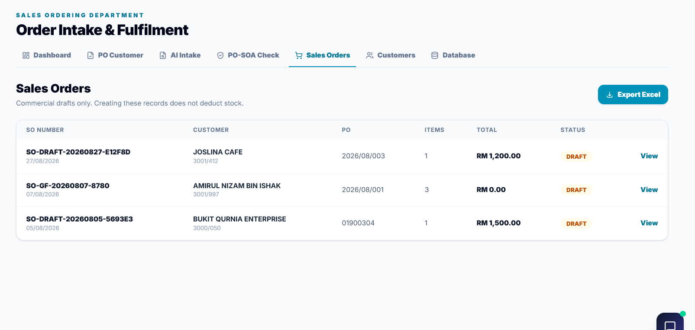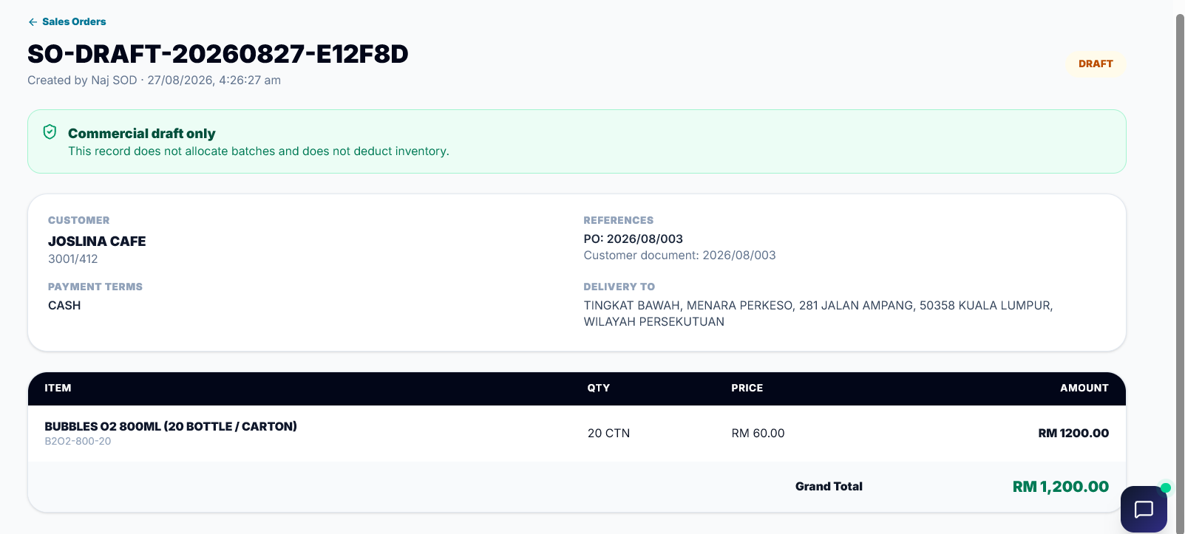
4.0 EXCEPTION HANDLING, FINANCIAL POLICIES & NOTIFICATIONS
To enforce strict financial discipline, the system implements automated controls for the following operational exceptions:
Exception Scenario | System Behavior | Required SOD / BD Operational Action
Order Rejected by Finance  (Credit REJECT) | Locks Sales Order creation and sends an automated email notification to the BD team. | Review the rejection remarks in the PO Customer or PO-SOA Check tab. BD must follow up with the client to collect overdue payments before resubmitting.
Credit Exception Override | Requires a Finance Officer to submit the APPROVE_EXCEPTION status. | Ensure that formal management approval or proof of partial payment is uploaded as an attachment for audit trail compliance.
Unreadable / Low Quality PDF | AI triggers an 'AI evaluation failed' warning if text is illegible. | Click Retry Intake to re-extract, or request a crisp digital PDF from the customer (avoid dark, skewed smartphone camera captures).
Duplicate SO Prevention | Blocks duplicate creation with error: 'Sales Order already exists for this document'. | Each Intake document is strictly mapped to one Sales Order to prevent double-booking of stock.

5.0 ROLES & PERMISSION MATRIX
System capabilities are restricted by assigned operational responsibilities:
Module / Operational Action | BD Staff | SOD Staff | Finance Reviewer | SuperAdmin
Review New Customer Registrations | ✅ | ✅ | 👁️ (View Only) | ✅
Approve / Reject Customer Registrations | ✅ | ❌ | ❌ | ✅
Upload Customer PO (AI Intake) | ✅ | ✅ | ❌ | ✅
Edit PO Line Items & Quantities | ✅ | ✅ | ❌ | ✅
Create Cash Draft Sales Orders | ❌ | ✅ | ❌ | ✅
Forward PO to Credit Check | ✅ | ✅ | ❌ | ✅
Upload SOA & Review Financial Rules | ❌ | ✅ | ✅ | ✅
Execute Finance Decisions (PROCEED/REJECT) | ❌ | ❌ | ✅ | ✅
Export Sales Orders to Excel | ❌ | ✅ | ✅ | ✅
System Reset & Purge Management | ❌ | ❌ | ❌ | ✅

6.0 SYSTEM RECOMMENDATIONS & BEST PRACTICES FOR SOD TEAM
To maintain high operational efficiency and avoid processing delays, SOD team members should observe the following five (5) best practices:
1. Prioritize Original Digital PDFs: Always upload computer-generated digital PDFs from customer accounting/ERP software rather than scanned physical printouts or phone photos. Digital PDFs achieve an AI extraction accuracy rate exceeding 99%.
2. Verify Customer Code Before Confirmation: Always verify that the matched Customer Code is accurate before creating a Sales Order to prevent billing errors and incorrect delivery routing.
3. Follow Up Promptly on 'Needs Review' Cases: For orders flagged with NEEDS_REVIEW (ON_HOLD), notify the assigned Finance Officer immediately to accelerate SOA ledger reconciliation.
4. Monitor the Dashboard Daily: Check the Dashboard every morning to review the Customer Order Rejected banner and ensure that all intake documents are cleared before the 12:00 PM cutoff.
5. Maintain Weekly Excel Archives: Perform a weekly Excel export of all approved Sales Orders every Friday afternoon for operational backup and weekly sales review meetings.

Link
Bubbles O2 Marketing Sdn Bhd - B2B Customer Registration - https://forms.gle/3HCi5Z9Szbyqvbfo6
Purchase Order Form - Bubbles O2 Marketing - https://forms.gle/cMSpur1ujyYSdUDg8
E-Invoice Corporate Forms - https://forms.gle/wdN9gE3sWvDVBcnf8

